**♠ Beauty / Ace of Spades ♤**

*The main protagonist of our story. She is beautiful and sweet-tempered. Her hobby is reading books. She appreciates intelligence and straightforwardness in others.*

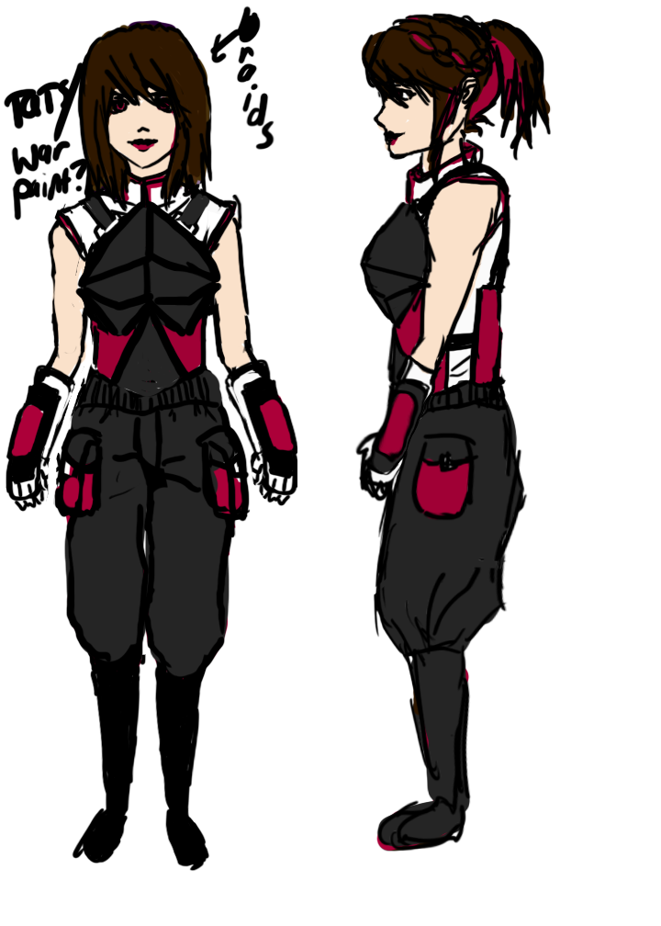

**mini-bio**

Unlike the other princesses, she comes from a humble background as a merchant’s daughter (not royalty or nobility), and has often felt snubbed or at least out of place amongst the other fairy tale protagonists.

**personality**

Loyal to family and friends, to the point of sacrificing herself for them (i.e. volunteers to go to Beast to save her father).

As Ace of Spades, she retains much of the same personality traits, but, like every other card soldier, has a fighter’s disposition and will try to evaluate people as either friend or foe when interacting with them. She has also gained some fighting abilities with knives, and is much more ruthless in her decisions. However, normally she carries a calm and nice demeanor. She has an unexplained revulsion of roses, but loves animals of all kinds. Unfortunately, the animals prefer the other princesses over her. Her tendency to do her best in her given circumstances (which defines her original personality) causes her to try to track down the other princesses with a single-mindedness that may seem unreasonable to others. When others ask her why she is working so hard to restore the original storyline, at first she will answer, “Because that is my wish,” but later on she will forget even why she wished for such a thing. For at least the beginning half of the novel, this is the side of her we will see, with glimpses of the true Beauty underneath.

**relationships**

**Beast:** She and Beast have one of the best marriage relationships amongst the royal couples. They love each other and also acknowledge each other as an equal. Their primary pastime is to debate and discuss various topics in the comforts of their living room, or go walking in the gardens that the Beast cares for. Because they are both avid readers, they have some idea of the nature of their world as a “fairy tale world,” with its own set of rules - this knowledge helps them to be one of the first to realize something is going wrong in the land.

**Cinderella**: BFF. Takes care of Cinderella.

**special points**

She owns a mirror that will allow her to see anything she wishes to see, provided that she has already seen it before.